SUTTON VALENCE PARISH COUNCIL
From the Clerk:
Mrs Janet Burnett E-mail: clerk@suttonvalence.org.uk The Parish Office Sutton Valence Village Hall Sutton Valence
Tel: 01622 844135 Maidstone
Web site: www.suttonvalencepc.kentparishes.gov.uk Kent ME17 3HS

Notice is hereby given of a remote meeting of the Parish Council to be held on Thursday January 14th 2021 at 7.00pm when the following business is proposed to be transacted:
The Chairman to ask if anyone is recording
Submissions from Public, Police, Community Support Warden, County or Borough Councillors
- Apologies for absence
- Declaration of lobbying
- Declaration of Changes to the Register of Interests
- Declaration of Interest in items on the Agenda
- Requests for Dispensation
- Minutes of the meetings held 12th November and 10th December 2020 to be agreed
- Covid 19
- CCTV Policy
- Social Media policy
- Electrical charging points
- Consultations
- KALC
- Website update
- Social media
- Training
- Data Protection
- Cloud document share
- Impact assessment
- Local Development Framework
- Neighbourhood Plan
- Website closure update
- Planning
- The following applications have gone to appeal at the Planning Inspectorate:
- The following applications have gone to appeal with the planning inspectorate:
20/501800/OUT Land Rear of Redic House Warmlake Road ME17 3LP. Outline application for the erection of three detached dwellings (Access and Layout being sought) as shown on drawings: 01A; 02A; and 03A - Parish Council has responded to this.
- 20/501090 Clothworkers Arms Lower Road ME17 3BL Proposal
Change of use from Class A4 (drinking establishment) to Class C3 (residential) and erection of two storey rear extension – Clerk will respond when application is on the Planning Inspectorate site.
- Finance
    - Authorisation of payments
    - Bank Balances
    - Income
    - Expenditure
    - Bank Reconciliation
- Performance against budget
- 2021/22 Budget to be approve
- Precept to be set

- Recreation and Open Spaces
- War Memorial Play Area and field
- Annual Play area inspection – quotes received – contractor to be approved
- Replacement fence – quotes received – contractor to be approved
- Car Park
- Football
- Tennis Court resurfacing update
Tender received – report distributed. Contractor to be approved.
- Harbour Play Area and field
- Weekly inspection
- Monthly inspection
- Open Spaces
- Extension of Conservation Area
- Parish Council field in South Lane
- Roads & Transport Group (inc. Lighting)
- Roads
- Public Transport
- Lighting
- Allotment
- Proposal that if Sutton Valence parishioners are on the waiting list for an allotment, they take precedence over non parishioners regardless of where they are on the waiting list.
- Proposal that contracts are amended to state that they would not be sent out annually but would run on unless there was a change in conditions.
- Police
- Correspondence
- Village Hall
- Agenda items for next meeting
- Date of next meeting

Janet Burnett – Clerk to the Council 8/1/21

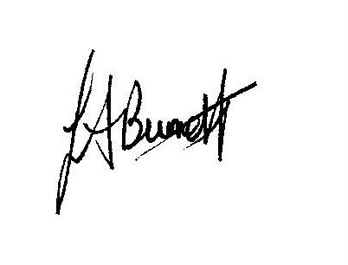

THIS MEETING IS TAKING PLACE REMOTELY ON ZOOM. IF YOU WISH TO ATTEND THE MEETING PLEASE
JOIN USING THE DETAILS BELOW

https://us02web.zoom.us/j/85964767977

