SUTTON VALENCE PARISH COUNCIL

From the Clerk:
Mrs Janet Burnett E-mail: clerk@suttonvalence.org.uk The Parish Office Sutton Valence Village Hall Sutton Valence
Tel: 01622 844135 Maidstone
Web site: www.suttonvalencepc.kentparishes.gov.uk Kent ME17 3HS

Notice is hereby given of a remote meeting of the Parish Council to be held on Thursday November 12th 2020 at 6.30pm when the following business is proposed to be transacted:
The Chairman to ask if anyone is recording
Submissions from Public, Police, Community Support Warden, County or Borough Councillors
- Apologies for absence
- Declaration of lobbying
- Declaration of Changes to the Register of Interests
- Declaration of Interest in items on the Agenda
- Requests for Dispensation
- Minutes of the meetings held 8th and 29th October 2020 to be agreed
- Financial regulations
- Covid 19
- Electrical charging points
- Consultations
- KALC meeting 23/11/20
- Website update
- Training –
- Chairing Virtual Meetings: Skills for Councillors” which is taking place via Zoom on Thursday 10th December - £35.00
- Effective Communication during Lockdown for Parish and Town Councils 13/11/20 – free. Clerk booked on.
- Data Protection
- Cloud document share
- Impact assessment
- Local Development Framework
- Neighbourhood Plan
- Proposal has been put forward to halt all works on the Neighbourhood Plan at the moment.
- Local Plan call for sites
- Planning
- Finance
    - Authorisation of payments
    - Bank Balances
    - Income
    - Expenditure
    - Bank Reconciliation
- Performance against budget
- External Audit
- 2021/22 Budget
- Recreation and Open Spaces
- War Memorial Play Area and field
- Annual Play area inspection
- Replacement fence
KCC Member grant - £1500.00 requested.
- Car Park
- Football
- Pavilion electricity contract renewal

- Tennis Court resurfacing – Invitation to tender for tennis court resurfacing
- Harbour Play Area and field
- Annual Play area inspection
- Open Spaces
- Extension of Conservation Area
- Parish Council field in South Lane
- Quad bike signage
- Roads & Transport Group (inc. Lighting)
- Kent Highways Seminar
- Public Transport
- Lighting – Clerk has instructed the lighting contractor to complete the repairs to two lights that have been vandalised
- Working groups
- Allotment
Recommendation on fees to be made for 2020/2021
- Police
- Correspondence
- Village Hall
- Agenda items for next meeting
- Date of next meeting

Janet Burnett – Clerk to the Council 6/11/20

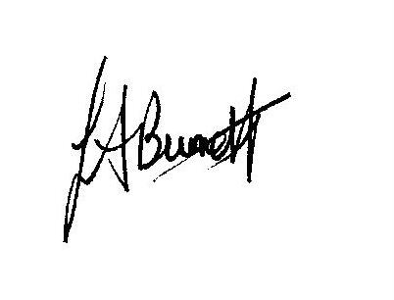

THIS MEETING IS TAKING PLACE REMOTELY ON ZOOM. IF YOU WISH TO ATTEND THE MEETING PLEASE
JOIN USING THE DETAILS BELOW

https://us02web.zoom.us/j/5018882891

