SUTTON VALENCE PARISH COUNCIL

From the Clerk:
Mrs Janet Burnett E-mail: clerk@suttonvalence.org.uk The Parish Office Sutton Valence Village Hall Sutton Valence
Tel: 01622 844135 Maidstone
Web site: www.suttonvalencepc.kentparishes.gov.uk Kent ME17 3HS

Notice is hereby given of a remote meeting of the Parish Council to be held on Thursday December 10th 2020 at 7.00pm when the following business is proposed to be transacted:
The Chairman to ask if anyone is recording
Submissions from Public, Police, Community Support Warden, County or Borough Councillors
- Apologies for absence
- Declaration of lobbying
- Declaration of Changes to the Register of Interests
- Declaration of Interest in items on the Agenda
- Requests for Dispensation
- Minutes of the meetings held 12th November 2020 to be agreed
- Covid 19
- Electrical charging points
- Consultations
- KALC meeting 23/11/20 and 28/11/2020
- Website update
- Social media
- Training
- Data Protection
- Cloud document share
- Impact assessment
- Local Development Framework
- Neighbourhood Plan
- Website closure update
- Local Plan call for sites
- Response from the Parish Council to the Consultation to be approved
- Planning
- The following planning applications to be considered
- 20/505345/FULL 1 Greensand Meadow ME17 3FP
Erection of single storey rear extension with light lanterns.
- 20/505350/FULL Warmlake Nursery Maidstone Road ME17 3LW
Redevelopment of existing garden nursery to provide 18 dwellings, including 7 affordable houses, with associated access and parking.
- Finance
    - Authorisation of payments
    - Bank Balances
    - Income
    - Expenditure
    - Bank Reconciliation
- Performance against budget
- 2021/22 Budget meeting to be set
- Recreation and Open Spaces
- War Memorial Play Area and field
- Annual Play area inspection
- Replacement fence
- Car Park

- Football
Decision to be made on whether to reconsider the football fees for 2020/21
- Tennis Court resurfacing update
- Harbour Play Area and field
- Annual Play area inspection
- Open Spaces
- Extension of Conservation Area
- Parish Council field in South Lane
- Roads & Transport Group (inc. Lighting)
- Kent Highways Seminar
- Public Transport
- Lighting
- Allotment
- Police
- Correspondence
- Village Hall
- Agenda items for next meeting
- Date of next meeting

Janet Burnett – Clerk to the Council 3/12/2020

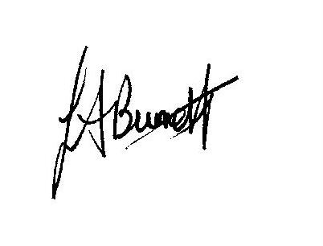

THIS MEETING IS TAKING PLACE REMOTELY ON ZOOM. IF YOU WISH TO ATTEND THE MEETING PLEASE
JOIN USING THE DETAILS BELOW

https://us02web.zoom.us/j/81617392186

