SUTTON VALENCE PARISH COUNCIL

From the Clerk:
Mrs Janet Burnett E-mail: clerk@suttonvalence.org.uk The Parish Office Sutton Valence Village Hall Sutton Valence
Tel: 01622 844135 Maidstone
Web site: www.suttonvalencepc.kentparishes.gov.uk Kent ME17 3HS

Notice is hereby given of a remote meeting of the Parish Council to be held on Thursday October 8th 2020 at 6.30pm when the following business is proposed to be transacted:
The Chairman to ask if anyone is recording
Submissions from Public, Police, Community Support Warden, County or Borough Councillors
- Apologies for absence
- Declaration of lobbying
- Declaration of Changes to the Register of Interests
- Declaration of Interest in items on the Agenda
- Requests for Dispensation
- Minutes of the meetings held 10th and 30th September 2020 to be agreed
- Financial regulations
- Accounting software – update
- Covid 19
- Electrical charging points
- Consultations
- KALC
- Website update
- Data Protection
- Cloud document share
- Impact assessment
- Local Development Framework
- Neighbourhood Plan
- Update
- Local Plan call for sites
- Planning
- Recommendation to be made on the following applications
- 20/504455/FULL Stallance Cottage Rectory Lane ME17 3BT
Demolition of existing single storey garage. Erection of a new garage with accommodation over, a new single storey home office outbuilding and a two storey side extension to the dwelling and enlargement of balcony decking.
- 20/504439/FULL Pancake Barn Boyton Court Road ME17 3BY
Change of use of existing outbuildings ancillary to the dwelling (Class C3) to use as holiday accommodation.
- Finance
    - Authorisation of payments
    - Bank Balances
    - Income
    - Expenditure
    - Bank Reconciliation
- Performance against budget
- 2021/22 Budget
- Recreation and Open Spaces
- War Memorial Play Area and field
- Annual Play area inspection
- Replacement fence
- Car Park

- Football
- Pavilion electricity contract renewal
- Tennis Court resurfacing – Invitation to tender for tennis court resurfacing
- Harbour Play Area and field
- Annual Play area inspection
- Open Spaces
- Extension of Conservation Area
- Quad bike signage
- Roads & Transport Group (inc. Lighting)
- Road closure – Clerk has been asked by RBL to arrange the road closure for the Remembrance Day Service. Risk assessment will be needed for this event.
- Public Transport
- Lighting
- Working groups
  - Allotment
20. Police
21. Correspondence
- Village Hall
- Toilet Door
- Agenda items for next meeting
- Date of next meeting

Janet Burnett – Clerk to the Council 2/10/20

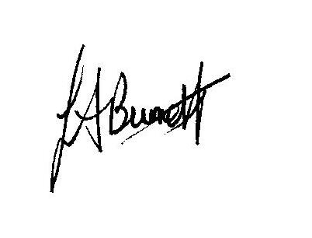

THIS MEETING IS TAKING PLACE REMOTELY ON ZOOM. IF YOU WISH TO ATTEND THE MEETING PLEASE
JOIN USING THE DETAILS BELOW
https://us02web.zoom.us/j/83499068752

