SUTTON VALENCE PARISH COUNCIL
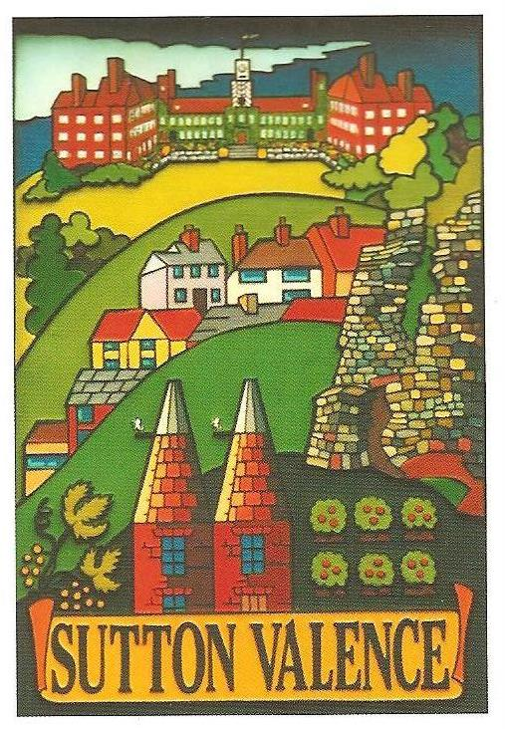 From the Clerk:
Mrs Janet Burnett E-mail: clerk@suttonvalence.org.uk The Parish Office Sutton Valence Village Hall Sutton Valence
Tel: 01622 844135 Maidstone
Web site: https://www.suttonvalencepc.org.uk Kent ME17 3HS

Notice is hereby given of a meeting of the Parish Council to be held in the committee room at the Village Hall on Thursday January 13th 2022 at 7:00pm when the following business is proposed to be transacted:
The Chairman to ask if anyone is recording
Submissions from Public, Police, Community Support Warden, County or Borough Councillors
- Apologies for absence
- To consider the 4 nominations received to fill the vacancies on Sutton Valence Parish Council by co-option.
- Declaration of lobbying
- Declaration of Changes to the Register of Interests
- Declaration of Interest in items on the agenda
- Requests for Dispensation
- Minutes of the meeting held 9th December 2021 to be agreed and signed
- To consider changing the date of the Parish Council meeting to enable it to be held in the main hall
- To consider the following policies previously circulated
- Expenses policy
- Grievance and disciplinary procedures.
- Health and safety policy
- Equal opportunities policy
- Grievance Policy
- Consultations
- Local Plan
- Parish Council housing meeting – CPRE meeting date to be set
- Emergency plan
- Memorial garden
- Electrical charging points
- KALC
- Newsletter
- Training
- Planning: recommendation to be made on:
- 21/506530/FULL Clothworkers Arms Lower Road Sutton Valence ME17 3BL
Change of use from a public house to 2no. dwelling houses, including demolition of existing timber balcony and staircase, and erection of single storey rear extension with roof terrace (part retrospective).
- The following recommendations made by the Clerk under delegated powers to be noted:
- 21/506413/LBC The Barn Court House Rectory Lane ME17 3BS Listed Building Consent for internal and external works in connection with conversion of the barn to create 1no. residential unit. – No comment
- 21/505458/REM Land Rear Of Redic House Warmlake Road ME17 3LP Approval of Reserved Matters for the erection of 3(no) detached dwellings with associated parking (Appearance, Landscaping, Layout, Scale being sought) pursuant of 20/504370/OUT (Outline application for erection of 3(no) detached dwellings with matters of access and layout being sought, appearance, landscaping and scale are reserved matters for future consideration) - No change to comments submitted 17/11/21

- 21/506412/FULL The Barn Court House Rectory Lane ME17 3BS
Conversion of barn to create 1no. residential unit alongside with the creation of amenity space, parking and access – No comment
- 21/506416/FULL 3 Valdene Close Sutton Valence Kent ME17 3GS
Erection of 1no. one bedroom annexe ancillary to main dwelling.
The Parish Council believes that this should be refused on the grounds of LP Policy DM11 as they believe that there will be a significant loss of privacy, light and outlook for the adjoining property
- Finance
    - Authorisation of payments
    - Bank Balances
    - Income
    - Expenditure
    - Bank Reconciliation
- Performance against budget
- 2022/23 budget to be approved
- Precept to be set
- Recreation and Open Spaces
- War Memorial Play Area and field
- Weekly and monthly inspections
- Annual Play area inspection
- Pavilion
Containers future to be discussed
Demolition
Porta cabins
- Football
- Harbour Play Area and field
- Weekly inspection
- Monthly inspection
- Annual inspection
- Open Spaces
- Extension of Conservation Area
- Sutton Valence Castle – letter from English Heritage
- Land at The Harbour
- MBC tree initiative.
- Tree survey
- Roads & Transport Group
- Bus shelters on North Street
- Tumblers Hill – to consider the response from KCC previously circulated
- Fire hydrant initiative project
- To consider the parking in the village.
- Lighting
- Allotment
- Police
- Correspondence
- Village Hall
- Agenda items for next meeting
- Date of next meeting
Janet Burnett – Clerk to the Council 7/1/22

