SUTTON VALENCE PARISH COUNCIL

From the Clerk:
Mrs Janet Burnett E-mail: clerk@suttonvalence.org.uk The Parish Office Sutton Valence Village Hall Sutton Valence
Tel: 01622 844135 Maidstone
Web site: www.suttonvalencepc.kentparishes.gov.uk Kent ME17 3HS

Notice is hereby given of a remote meeting of the Parish Council to be held on Thursday April 8th 2021 at 7.00pm when the following business is proposed to be transacted:
The Chairman to ask if anyone is recording
Submissions from Public, Police, Community Support Warden, County or Borough Councillors
- Apologies for absence
- Declaration of lobbying
- Declaration of Changes to the Register of Interests
- Declaration of Interest in items on the Agenda
- Requests for Dispensation
- Minutes of the meetings held 11th and 25th March 2021 to be agreed
- Covid 19
To consider giving the Clerk delegated powers to deal with urgent items and to make payments until 21st June 2021
Date of the Annual Parish Council Meeting
Welcome Back Fund
Memorial garden
Letter to Luke Hall MP
- Delivering the Green Agenda
- Assets of Community Value
- Rural Market Town Group
- Electrical charging points
- Consultations
- KALC
- Social media
- Training
- Data Protection
- Planning
- Recommendation to be made on the following applications:
21/500602/LBC The Swan Broad Street ME17 3AJ - Listed Building Consent for retention of ground and first floor layout further to application 14/506379/LBC (works complete).
- Finance
    - Authorisation of payments
    - Bank Balances
    - Income
    - Expenditure
    - Bank Reconciliation
- Performance against budget
- External Audit
- Internal Audit
- Recreation and Open Spaces
- War Memorial Play Area and field
- Weekly and monthly inspections
- Annual Play area inspection – awaiting repairs
- Replacement fence – completed
- Car Park
- Pavilion update

- Football
- Tennis Court
- Electrical and water supply to the tennis courts and hut.
- Resurfacing update
- Harbour Play Area and field
- Weekly inspection
- Monthly inspection
- Open Spaces
- Grass cutting and maintenance schedule
- Extension of Conservation Area
- Parish Council field in South Lane
- Tree survey
- PROW
- Roads & Transport Group (inc. Lighting)
- Roads
- Public Transport
- Lighting
- Allotment
Cllr Ward to report
- Police
- Correspondence
- Village Hall
- CCTV
- Agenda items for next meeting
- Date of next meeting

Janet Burnett – Clerk to the Council 31/3/21

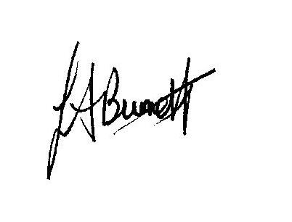

THIS MEETING IS TAKING PLACE REMOTELY ON ZOOM. IF YOU WISH TO ATTEND THE MEETING PLEASE
JOIN USING THE DETAILS BELOW

https://us02web.zoom.us/j/83394030715

